Llangrannog Trip 2025
From the 20th–22nd of November, 44 Year 8 pupils and nine Year 12 Welsh A-Level students enjoyed a bright but cold weekend of adventure at Gwersyll yr Urdd Llangrannog.
Pupils took part in a huge range of activities, including the zip line, wall climbing, high ropes, go-karting, quad biking, skiing, tobogganing, an escape room, and more! Many pushed themselves to try something new and faces new challenges with enthusiasm, resilience and plenty of smiles.
Miss Griffiths, Mr Morgan and Mrs Ellis were especially pleased to hear pupils confidently using their Welsh throughout their stay, taking full advantage of the centre’s completely Welsh-speaking environment.
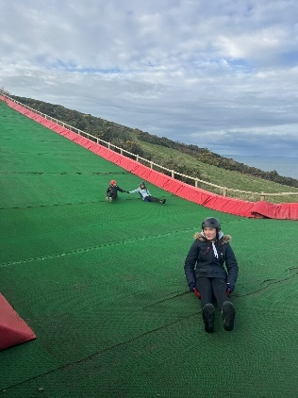
It was a weekend full of fun, challenge and brilliant memories – Diolch i chi gyd!


